IMPACT OF INFLUENCER MARKETING ON FASHION BUYING BEHAVIOUR AMONG EARLY AND LATE GEN Z CONSUMERS

ABSTRACT :

The present study aims to examine the impact of influencer marketing on fashion buying behaviour among Early and Late Generation Z consumers in Mumbai. The study also analyses the role of influencer credibility, measured through trustworthiness, expertise, and attractiveness, in influencing purchase intention. A quantitative research design is adopted, and primary data will be collected through a structured questionnaire using a 5-point Likert scale from 150 Generation Z respondents in Mumbai.
The findings of the study are expected to provide insights into generational differences within Gen Z and help fashion brands design more effective influencer marketing strategies tailored to specific consumer segments.

KEYWORDS :

Influencer Marketing, Fashion Buying Behaviour, Generation Z, Early Gen Z, Late Gen Z, Social Media Marketing, Consumer Behaviour

INTRODUCTION:
Overview of the topic
The rapid advancement of digital technologies and social media platforms has fundamentally transformed marketing communication strategies. Influencer marketing has emerged as a dominant promotional tool, particularly within the fashion industry, where visual appeal and social validation significantly influence consumer behaviour.
Influencers function as digital opinion leaders who impact consumer attitudes and purchase intentions through curated content, endorsements, and brand collaborations. Generation Z, born between 1997 and 2012, represents a highly digital-native consumer group that actively engages with influencer-generated content.
However, Generation Z is not homogeneous. It consists of Early Gen Z (1997–2003) and Late Gen Z (2004–2012), who differ in purchasing capacity, psychological maturity, and exposure to digital environments. These differences may lead to variations in responsiveness toward influencer marketing strategies.
Therefore, this study seeks to examine the impact of influencer marketing on fashion buying behaviour while comparing Early and Late Generation Z consumers in Mumbai.
Overview of the industry
The fashion industry is one of the largest and fastest-growing global industries, driven by trends, consumer preferences, and digital innovation. In recent years, the industry has undergone a major transformation due to the rise of social media, e-commerce, and influencer marketing. Fashion brands increasingly rely on digital platforms such as Instagram, TikTok, and YouTube to promote products and engage with consumers, especially younger audiences like Generation Z.
Within the fashion sector, influencer marketing has proven highly effective in shaping consumer behaviour. Studies show that 67% of Gen Z fashion purchases are influenced by Instagram influencers, while nearly half of consumers trust influencer recommendations more than traditional advertisements.Generation Z represents a key target market for the fashion industry because they are highly active on social media and rely heavily on digital content when making purchase decisions. Many Gen Z consumers prefer authentic recommendations from influencers rather than traditional brand advertising, which has increased the importance of influencer credibility, including trustworthiness, expertise, and attractiveness. Overall, the fashion marketing industry is becoming increasingly digital, influencer-driven, and consumer-centric.

Conceptual framework
- Independent Variable: Influencer Marketing
- Mediating Variable: Influencer Credibility, Trustworthiness, Expertise, Attractiveness
- Dependent Variable: Fashion Buying Behaviour
- Moderating Variable: Early Gen Z and Late Gen Z
- Proposed Relationship: Influencer Marketing
↓
Influencer Credibility
↓
Fashion Buying Behaviour
(Moderated by Early vs Late Gen Z)

Significance of the Paper :
- Understanding differences between early and late Gen Z helps brands design better marketing strategies, improve engagement, and increase conversion rates.
- It highlights the differences between Early and Late Gen Z, which can help marketers customize campaigns according to age-specific preferences.
- The research adds to existing literature by specifically comparing Early and Late Gen Z rather than studying Gen Z as a single group.
- It helps understand how credibility influences online consumer behaviour in the digital era.
- The study provides insights to fashion brands about how influencer credibility affects the buying behaviour of Early and Late Generation Z, helping them design more effective marketing strategies.

RESEARCH METHODOLOGY :

Sources of Data:
This study uses both primary and secondary data.
1. Primary Data – Questionnaire
2. Secondary Data – Academic journals, research papers, books
Research Design:
This research is a descriptive research.
Type of Study:
The type of study used is quantitative analysis.
Area:
The area under study is Mumbai.
Target Population:
The target population of this study consists of Generation Z consumers aged 18–27 who actively used social media and are exposed to influencer marketing related to fashion products
Sampling Technique:
The technique used is a convenience sampling method.
Sample Size:
The sample size of the study is 109 respondents.
Data Collection Tool:
The data for the study was collected using a Structured questionnaire.
Statistical Tools:
The data collected was analysed by using following statistical tools.
1 .Non parametric
2. Descriptive Statistics. ( Percentage analysis)
3. Cross tabulation.
4. Chi square test of association.

OBJECTIVES :

- To study influencer marketing
- To study the differences between Early and Late Gen Z
- To analyse the relationship between influencer credibility and fashion buying behaviour.
- To examine the influence of influencer marketing on fashion buying behaviour among Generation Z consumers in Mumbai.
- To compare Early and Late Generation Z consumers in terms of their responsiveness to influencer marketing.

HYPOTHESIS :

H₁: Influencer marketing significantly influences fashion buying behaviour among Generation Z consumers.
H₂: There is a significant difference between Early and Late Generation Z consumers regarding influencer-driven fashion buying behaviour.

SCOPE OF RESEARCH :
The scope of this study focuses on understanding the impact of influencer marketing on fashion buying behaviour among Generation Z consumers. The research examines the role of influencer credibility, including trustworthiness, expertise, and attractiveness, in influencing purchase decisions. The study is limited to Generation Z consumers in Mumbai and compares the responses of Early Gen Z and Late Gen Z individuals. Data for the study is collected from 109 respondents using a structured questionnaire and analysed using statistical tools such as percentage analysis, cross tabulation, and chi-square test.

REVIEW OF LITERATURE :
Existing literature highlights that Generation Z is a digitally native generation whose purchasing behaviour is strongly shaped by online platforms and social media environments. Several studies (Marusic et al., 2024; Zhulal et al., 2024; Ridwan et al., 2023) indicate that Gen Z prefers online shopping due to convenience, accessibility, and smartphone dependency. These studies emphasize that Gen Z consumers are highly analytical, price-conscious, and influenced by online reviews rather than traditional advertising. Trust and convenience emerge as significant determinants of online purchasing behaviour.
Studies on electronic word-of-mouth (Haroon et al., 2025; Eandhizhai et al., 2025) reveal that information quality, usefulness, and credibility positively influence Gen Z’s purchase intention. These findings establish that credibility plays a central role in shaping online consumer behaviour.
While these studies provide strong evidence that influencer marketing and credibility significantly influence Gen Z’s purchase behaviour, most research treats Generation Z as a homogeneous group. Limited attention has been given to internal generational differences within Gen Z.Comparative analysis between Early Gen Z (1997–2003) and Late Gen Z (2004–2012) remains underexplored, particularly in the context of fashion purchasing behavior.

RESEARCH GAP :

Although extensive research exists on influencer marketing and Generation Z, limited comparative studies analyse internal segmentation within Gen Z. Specifically, there is insufficient empirical evidence examining whether Early and Late Generation Z consumers differ in their fashion buying behaviour influenced by social media influencers in Mumbai. This study aims to address this gap.

LIMITATION

- The study relies on questionnaire responses, and answers may be biased or influenced by personal perception.
- The study focuses mainly on influencer credibility and buying behaviour, and does not consider other factors like cultural background, brand loyalty.
- The study is geographically restricted to Mumbai.
- The use of convenience sampling may limit generalisability.
- Responses are subject to personal bias.

DATA ANALYSIS:

Contingency Tables (1,6)
Contingency Tables
 | B
A | 6.How often do you purchase fashion products ? | Once a month | Rarely | Once in 2-3 months | Occasionally | Total
1.Age | 4 | 0 | 0 | 0 | 0 | 4
22 - 27 (Early GenZ) | 0 | 132 | 28 | 72 | 84 | 316
18 - 21 (Late GenZ) | 0 | 36 | 24 | 32 | 28 | 120
Total | 4 | 168 | 52 | 104 | 112 | 440

χ² Tests
 | Value | df | p
χ² | 453 | 8 | <.001
N | 440
Interpretations:
The chi-square test was conducted to examine whether there is a significant difference between Early Gen Z and Late Gen Z consumers in terms of their fashion purchasing frequency. Since the p-value is less than 0.05 (p < 0.001), the result is statistically significant. Therefore, H₂ is accepted, indicating that there is a significant difference between Early and Late Generation Z consumers regarding influencer-driven fashion buying behaviour.

Contingency Tables (1,8)
Contingency Tables
 | B
A | 8.How often do you view fashion related influencer content? | Daily | Rarely | Occasionally | Weekly | Total
1.Age | 4 | 0 | 0 | 0 | 0 | 4
22 - 27 (Early GenZ) | 0 | 124 | 56 | 84 | 52 | 316
18 - 21 (Late GenZ) | 0 | 48 | 12 | 32 | 28 | 120
Total | 4 | 172 | 68 | 116 | 80 | 440

χ² Tests
 | Value | df | p
χ² | 446 | 8 | <.001
N | 440
Interpretations:
The chi-square test was conducted to examine the relationship between age group (Early Gen Z and Late Gen Z) and frequency of viewing fashion-related influencer content. The results show that the p-value is less than 0.05 (p < 0.001), indicating a statistically significant relationship between the variables. Therefore, H₂ is accepted, which means that there is a significant difference between Early and Late Generation Z consumers in terms of their responsiveness to influencer marketing.

(1,12)
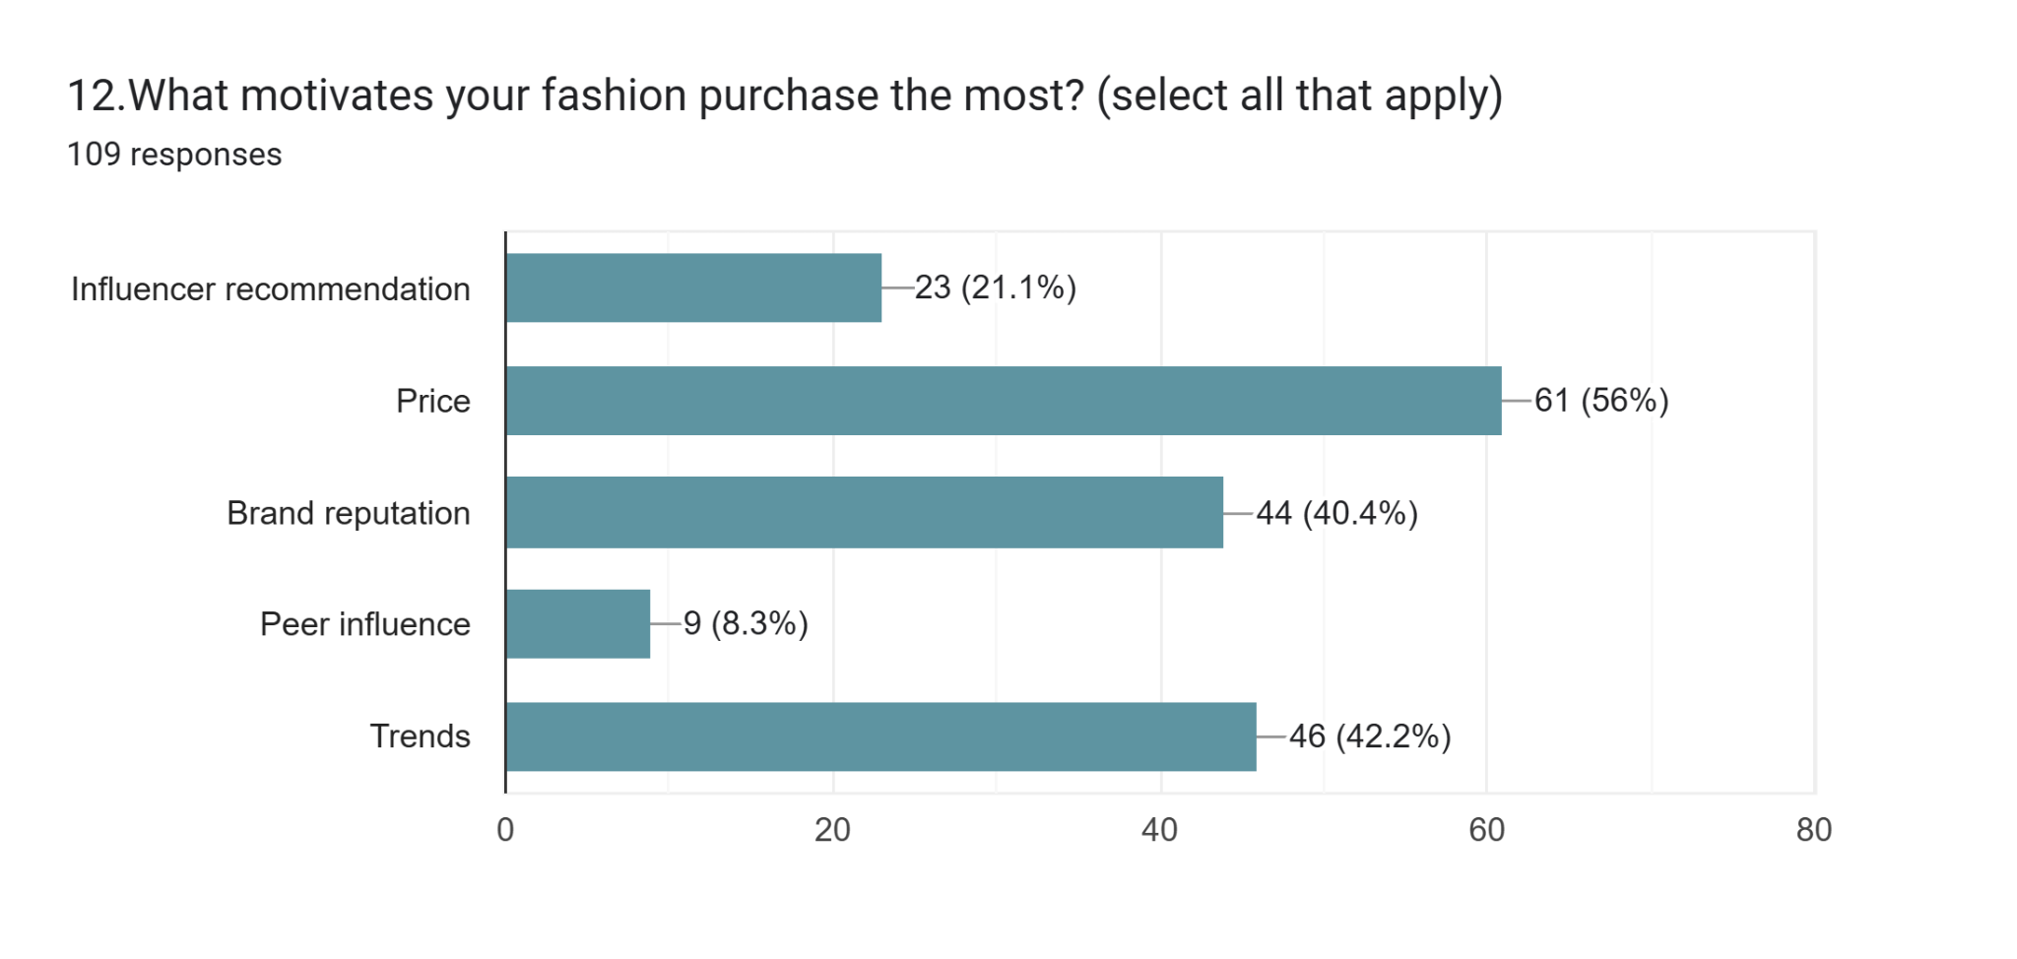

Contingency Tables (1,12)
Contingency Tables
 | A
B | 1.Age | 22 - 27 (Early GenZ) | 18 - 21 (Late GenZ) | Total
12.What motivates your fashion purchase the most? (select all that apply) | 4 | 0 | 0 | 4
Trends | 0 | 48 | 24 | 72
Trends, Influencer recommendation | 0 | 4 | 0 | 4
Influencer recommendation, Price | 0 | 12 | 8 | 20
Price, Trends | 0 | 28 | 12 | 40
Price | 0 | 56 | 20 | 76
Price, Brand reputation | 0 | 52 | 8 | 60
Influencer recommendation | 0 | 12 | 12 | 24
Brand reputation | 0 | 28 | 12 | 40
Price, Brand reputation, Trends | 0 | 8 | 8 | 16
Price, Brand reputation, Peer influence | 0 | 0 | 4 | 4
Peer influence | 0 | 8 | 4 | 12
Influencer recommendation, Price, Brand reputation, Peer influence, Trends | 0 | 12 | 0 | 12
Influencer recommendation, Brand reputation | 0 | 4 | 4 | 8
Influencer recommendation, Price, Brand reputation | 0 | 8 | 0 | 8
Influencer recommendation, Trends | 0 | 4 | 0 | 4
Influencer recommendation, Brand reputation, Trends | 0 | 4 | 0 | 4
Influencer recommendation, Price, Trends | 0 | 4 | 0 | 4
Brand reputation, Trends | 0 | 16 | 0 | 16
Peer influence, Trends | 0 | 0 | 4 | 4
Brand reputation, Peer influence, Trends | 0 | 4 | 0 | 4
Influencer recommendation, Price, Brand reputation, Trends | 0 | 4 | 0 | 4
Total | 4 | 316 | 120 | 440

χ² Tests
 | Value | df | p
χ² | 506 | 42 | <.001
N | 440

Interpretations:

The contingency table analysis shows that price, trends, and brand reputation are the major factors influencing fashion purchase decisions among Generation Z consumers. Influencer recommendations also affect buying behaviour but mainly when combined with other factors such as price or brand reputation. A comparison between Early Gen Z (22–27) and Late Gen Z (18–21) indicates differences in the importance given to these factors.
The Chi-square test result (χ² = 506, p < 0.001) shows that the relationship between age group and motivating factors is statistically significant. H₂ is accepted,which means that fashion purchase motivations vary between Early and Late Generation Z consumers.

Contingency Tables (8,6)
Contingency Tables
 | A
B | 8.How often do you view fashion related influencer content? | Daily | Rarely | Occasionally | Weekly | Total
6.How often do you purchase fashion products ? | 4 | 0 | 0 | 0 | 0 | 4
Once a month | 0 | 88 | 16 | 32 | 32 | 168
Rarely | 0 | 16 | 20 | 12 | 4 | 52
Once in 2-3 months | 0 | 40 | 8 | 28 | 28 | 104
Occasionally | 0 | 28 | 24 | 44 | 16 | 112
Total | 4 | 172 | 68 | 116 | 80 | 440

χ² Tests
 | Value | df | p
χ² | 502 | 16 | <.001
N | 440
Interpretations:
The contingency table shows the relationship between how often Generation Z consumers view fashion-related influencer content and how often they purchase fashion products. The results indicate that respondents who view influencer content more frequently (daily or occasionally) tend to purchase fashion products more frequently, such as once a month or occasionally. This suggests that exposure to influencer content can influence consumers' fashion purchasing behaviour. The Chi-square test result shows χ² = 502 with p ≤ 0.01 (N = 440). Since the p-value is less than 0.05, the result is statistically significant.Therefore H₁ is accepted , which means there is a significant relationship between viewing influencer content and fashion purchasing frequency among Generation Z consumers.

Contingency Tables (8,12)
Contingency Tables
 | A
B | 8.How often do you view fashion related influencer content? | Daily | Rarely | Occasionally | Weekly | Total
12.What motivates your fashion purchase the most? (select all that apply) | 4 | 0 | 0 | 0 | 0 | 4
Trends | 0 | 20 | 16 | 24 | 12 | 72
Trends, Influencer recommendation | 0 | 4 | 0 | 0 | 0 | 4
Influencer recommendation, Price | 0 | 12 | 0 | 0 | 8 | 20
Price, Trends | 0 | 8 | 4 | 8 | 20 | 40
Price | 0 | 36 | 12 | 16 | 12 | 76
Price, Brand reputation | 0 | 12 | 12 | 24 | 12 | 60
Influencer recommendation | 0 | 4 | 8 | 8 | 4 | 24
Brand reputation | 0 | 20 | 12 | 4 | 4 | 40
Price, Brand reputation, Trends | 0 | 4 | 0 | 8 | 4 | 16
Price, Brand reputation, Peer influence | 0 | 4 | 0 | 0 | 0 | 4
Peer influence | 0 | 0 | 4 | 8 | 0 | 12
Influencer recommendation, Price, Brand reputation, Peer influence, Trends | 0 | 4 | 0 | 8 | 0 | 12
Influencer recommendation, Brand reputation | 0 | 8 | 0 | 0 | 0 | 8
Influencer recommendation, Price, Brand reputation | 0 | 8 | 0 | 0 | 0 | 8
Influencer recommendation, Trends | 0 | 4 | 0 | 0 | 0 | 4
Influencer recommendation, Brand reputation, Trends | 0 | 4 | 0 | 0 | 0 | 4
Influencer recommendation, Price, Trends | 0 | 4 | 0 | 0 | 0 | 4
Brand reputation, Trends | 0 | 12 | 0 | 4 | 0 | 16
Peer influence, Trends | 0 | 4 | 0 | 0 | 0 | 4
Brand reputation, Peer influence, Trends | 0 | 0 | 0 | 4 | 0 | 4
Influencer recommendation, Price, Brand reputation, Trends | 0 | 0 | 0 | 0 | 4 | 4
Total | 4 | 172 | 68 | 116 | 80 | 440

χ² Tests
 | Value | df | p
χ² | 660 | 84 | <.001
N | 440
Interpretations:
The Chi-square test was conducted to examine the relationship between how often Generation Z consumers view fashion influencer content and what motivates their fashion purchases.Since the p-value is less than 0.05, the result is statistically significant.Therefore H₁ is accepted , which means there is a significant relationship between exposure to fashion influencer content and the factors that motivate fashion purchases among Generation Z consumers.Therefore, the analysis highlights the growing impact of influencer marketing in influencing consumer purchase decisions within the fashion industry.

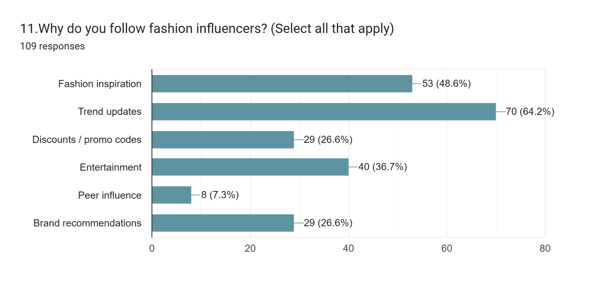

(10,11)

χ² Tests
 | Value | df | p
χ² | 2026 | 420 | <.001
N | 440

Interpretations:

The data analyses the reasons why Generation Z consumers follow fashion influencers on social media. The responses indicate that trend updates are the most important reason, selected by 70 respondents (64.2%), suggesting that influencers play a major role in keeping consumers informed about the latest fashion trends.The second most common reason is fashion inspiration, chosen by 53 respondents (48.6%), which shows that influencers significantly inspire consumers' fashion styles and choices. Additionally, entertainment was selected by 40 respondents (36.7%), indicating that engaging and entertaining content also attracts followers.
The Chi-square test results show χ² = 2026 with 420 degrees of freedom and a p-value less than 0.001. Since the p-value is lower than the significance level of 0.05, the result is statistically significant. Therefore H₁ is accepted,which means that the reasons for following fashion influencers are significantly associated with consumer engagement and behaviour among Generation Z.
Overall, the findings highlight the strong role of influencer marketing in shaping consumer interests, fashion awareness, and engagement with fashion-related content.

SUMMARY OF THE ANALYSIS:

The analysis of the collected data indicates that influencer marketing plays a significant role in shaping the fashion buying behaviour of Generation Z consumers. The findings show that influencer credibility, including trustworthiness, expertise, and attractiveness, has a noticeable impact on consumer purchase decisions. The statistical analysis using cross tabulation and chi-square test reveals that there is a significant difference between Early Gen Z and Late Gen Z consumers in their responsiveness to influencer-driven fashion content. Overall, the results suggest that influencer marketing is an effective strategy in influencing fashion-related purchasing behaviour among Generation Z consumers in Mumbai.

FINDINGS OF THE STUDY:

1.The study found that influencer marketing has a significant impact on the fashion buying behaviour of Generation Z consumers.
2.Influencer credibility, including trustworthiness, expertise, and attractiveness, plays an important role in influencing consumers' purchase decisions.
3.A large number of respondents frequently view fashion-related influencer content on social media platforms.
4.The analysis shows that social media influencers affect the purchasing decisions of Gen Z consumers when buying fashion products.
5.The chi-square test results indicate that there is a significant difference between Early Gen Z and Late Gen Z consumers in their responsiveness to influencer marketing.
6.Overall, influencer marketing is an effective promotional strategy for fashion brands targeting Generation Z consumers.

CONCLUSION:

The analysis shows that early Gen Z consumers (22-27 years) form the majority of the respondents and tend to show greater engagement with influencer content, as they are more financially independent and capable of making purchasing decisions. They are more likely to explore brand websites, follow fashion influencers, and consider influencer recommendations when evaluating fashion products.
On the other hand, late Gen Z consumers (18-21 years) are also highly influenced by social media trends but tend to engage with influencer content mainly for fashion inspiration, entertainment, and trend awareness. Their purchasing behaviour is comparatively more price-sensitive, as many of them are students or financially dependent.
The findings also indicate that while influencer marketing plays an important role in shaping fashion awareness and brand discovery for both groups, the final purchase decision is influenced by additional factors such as price, brand reputation, and personal style preferences.
Overall, the analysis suggests that influencer marketing has a stronger impact on awareness and product consideration rather than immediate purchase, with early Gen Z showing slightly higher purchase engagement compared to late Gen Z consumers.
The study concludes that influencer marketing has a significant impact on the fashion buying behaviour of Generation Z consumers. Social media influencers play an important role in shaping consumer preferences and purchase decisions through their content and recommendations. The findings also indicate that influencer credibility, including trustworthiness, expertise, and attractiveness, influences consumers’ attitudes towards fashion products. Furthermore, the study highlights that there is a significant difference between Early Gen Z and Late Gen Z consumers in their responsiveness to influencer marketing. Overall, influencer marketing has emerged as an effective promotional strategy for fashion brands targeting Generation Z consumers.

SUGGESTIONS:

Fashion brands should collaborate with credible influencers who are trusted by Generation Z consumers to increase the effectiveness of marketing campaigns.
Brands should focus on creating authentic and engaging content, as Gen Z consumers are more likely to trust influencers who provide honest opinions about products.
Companies should select influencers whose personality and style match the brand image, as attractiveness and expertise influence consumer perception.
Fashion brands should use social media platforms such as Instagram, YouTube, and TikTok more actively to reach Generation Z audiences.
Marketers should design different influencer marketing strategies for Early Gen Z and Late Gen Z, as the study shows differences in their responsiveness to influencer marketing.

